**MOBILE APPLICATIONS LAB 2**

**NAME: LENA GEO**

**REGISTER NUMBER: 2241139**

**CODE:**

**MainActivity.kt**

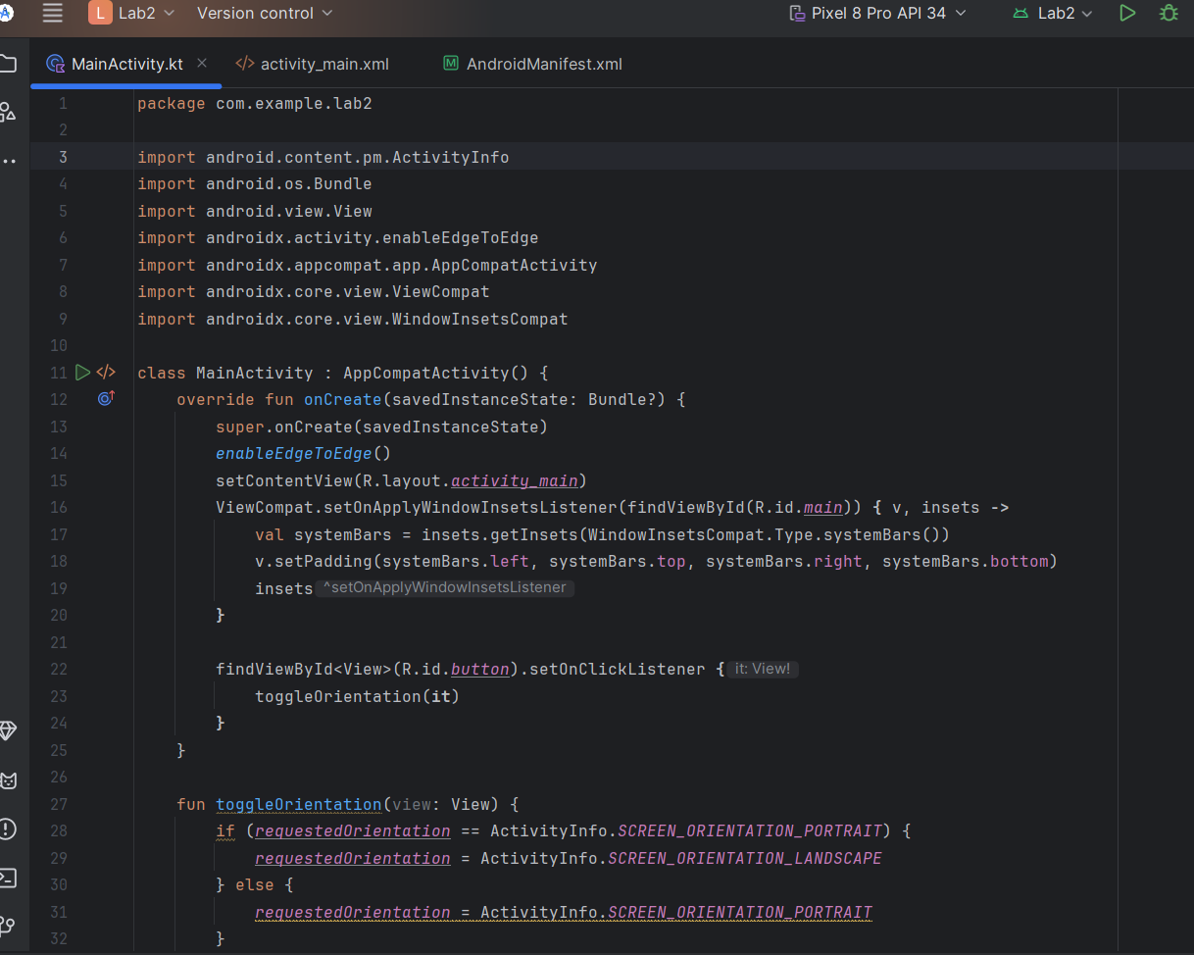

**activity_main.xml**

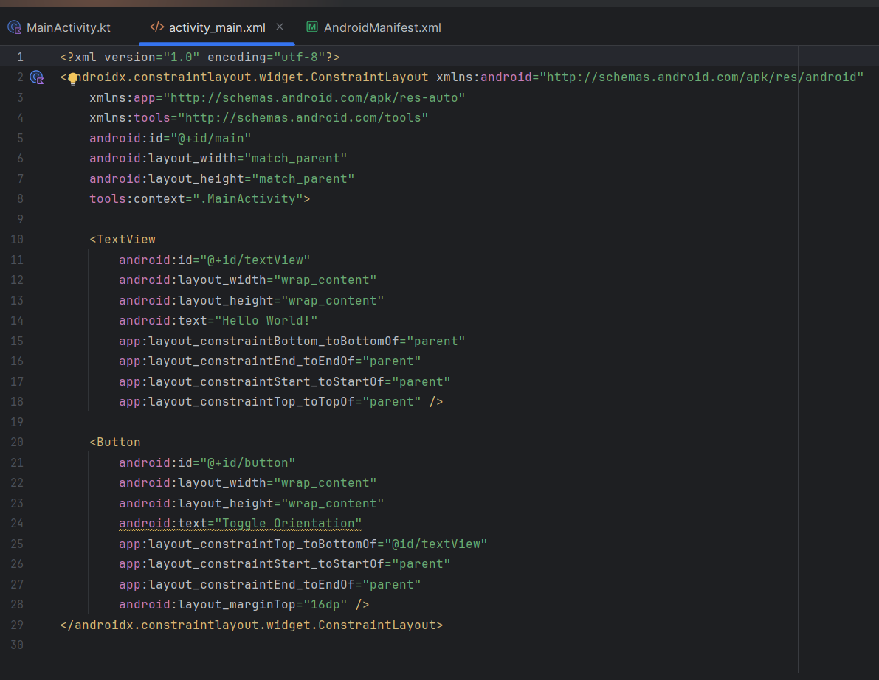

**AndroidManifest.xml**

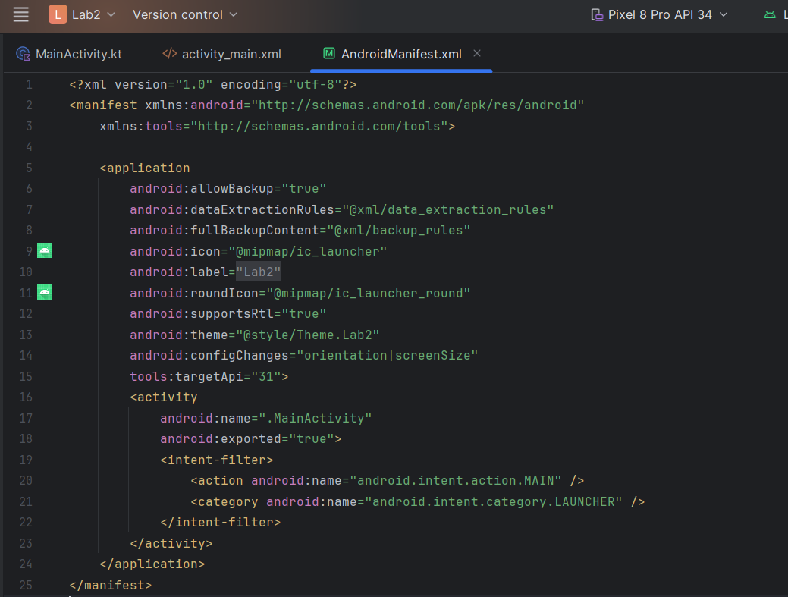

**Output:**

